

**GEN 203: Ecological System and Environment**

**Case Study**

Environmental condition in and around Uttar Khan

**Submitted to:**

Dr. Asib Ahmed

Associate Professor

Department of Geography and Environment, University of Dhaka.

**Submitted by:**

Sheikh Sarafat Hossain   
**ID**: 2022-3-60-109  
**Section:** 02

**Date of submission:** 13.09.2024

Table of Contents

Introduction: 2

Objective of the case study: 4

Study Area: 6

Defining environment: 7

Major environmental issues: 7

Level of pollution: 11

Methodology: 13

Result of the Study Area: 13

Positive initiatives: 14

Discussion: 14

Conclusion: 15

# Introduction:

The environment is anything that is surrounding us. It emphasizes the interplay of all living organisms, including animals, plants, and human beings, as well as non-living elements such as air, water, and nature. It can be affected by both natural and human induced activity, which refers to environmental pollution. Any alteration to air, water, soil that affects any living organism is called environmental pollution. It can occur due to pollutants like chemicals, waste and gases. Now, this is a significant issue affecting the balance between human life and the ecosystem in the whole world. Global environment pollution is responsible for climate change, global warming, natural disaster, Sea level rising and loss of species.

Bangladesh is a low-lying, overpopulated and developing country. It has a coastline of 580 km along with the northern coast of the Bay of Bengal. It experiences high temperature, high humidity and significant seasonal changes in rainfall due to sub-tropical monsoon (Source: Geography of Bangladesh, Wikipedia). Over the few decades, it faced huge environmental loss such as water pollution, air pollution, land pollution, deforestation and loss of biodiversity. Almost every year, cyclones, floods and river erosion destroy numerous lives, property and infrastructure in Bangladesh. Bangladesh’s rank in Environmental pollution Index (EPI) is fourth from the bottom (27.8 points). Due to environmental issues, level of development and economic structure environmental risk is a big challenge for Bangladesh. In the purpose of both Bangladesh’s development and economic growth, the priority is to deal with environmental threat because Bangladesh can never ignore the nature and environment (Abdoulaye Seck, Country Director for Bhutan and Bangladesh).

(Source: Mohammad Al-Masum Molla, The Daily Star)

Most polluted city in Bangladesh is Dhaka city. It has an Air Quality Index (AQI) score of 244 and is ranked top globally on 1st January 2024. Dhaka city’s air is classified as “Unhealthy air” (Source: UNB). Gazipur, Savar, Tejgaon industrial area are the primary sources of air pollution in Dhaka city. The Buriganga River causes major water pollution in Dhaka City. Other water bodies such as Turag, Balu, Sitalakhya rivers are also sources of water pollution. Moreover, Haitirheel and Dhanmondi lake also suffer from domestic and agricultural waste. On the other hand, hotspot land pollution is caused by Hazaribagh tannery industry. Besides, noise pollution from traffic is a regular scene on the roads of this city.

# Objective of the case study:

In this case study I will highlight environmental pollution in and around my locality “Uttar Khan”. Environmental pollution is a serious issue in my locality, and it has a harmful impact on the health and wellbeing of the residents. My goal is to identify current environmental conditions in my locality and to investigate current initiatives to protect environmental challenges. This case study may be helpful to understanding local issues, sources of pollution, long-term consequences of pollution like climate change, loss of biodiversity and health crisis and public awareness. This case study will inspire readers to consider their involvement in environmental protection for long-term growth and future well-being.

# Study Area:

Uttar khan is a sub-urban area of 35 square kilometers, and it is in northern Dhaka city. It has population about 1,400,000 people where 78,200 males and 63,800 females. The neighbors of Uttar khan are- Dakshin khan and Khilkhet. Hazrat Shahjalal International Airport is also near this area. Tongi Khal and Balu River are also notable water bodies in our area. (Source: Uttarkhanup.dhaka.gov.bd)

# Defining environment:

Our Uttar Khan area is surrounded by natural beauty and huge greenery. There are 5023 acres of agricultural land because most of the people are landowners. There are also urbanized and developing sites. The environment also includes 68 numbers of ponds, canals and lakes. Besides, here are number of 76 Garments factory, chemical industries and other small industries. There is also a recreational area named “Green view resort” located in Moinertek, Uttar khan. (Source: Uttarkhanup.dhaka.gov.bd)

# Major environmental issues:

As a developing, populated and rapid urbanized area, Uttar khan have major environmental issues that are mentioned below: -

* **Air Pollution:** Once our area provided fresh breathable air. But recently, industrial and road construction dust contributes to high level degradation of air. Open burning waste and irregular waste collection is another main reason for degrading air quality. Airport jams are a regular scene that not only pollutes the air but also pollutes sound. Vehicles and factories eject harmful smoke and gases from exhaust pipes. It includes nitrogen oxide, sulfur oxide and hydrocarbons.
* **Land Pollution:** Uttar Khan has many lands and fertile soil for agriculture. Using fertilizer, pesticides and chemicals are degrading the soil quality. Mostly waste generates methane in landfills. Poor drainage system causes land pollution. Numerous plastics and non-biodegradable elements are polluting lands. Mining creates land erosion, dust and deforestation.
* **Water pollution:** Tongi Khal and Balu River are polluted due to tanneries, oil, plastics and toxic factory wastage. Ponds and canals are polluted by raw sewage and household waste. Fertilizer and Chemicals from agricultural runoff are also affecting water. Leakage in waste disposal pollutes groundwater. In addition, land pollution is also a source of ground water pollution. As a result, water becomes unsuitable for drinking.

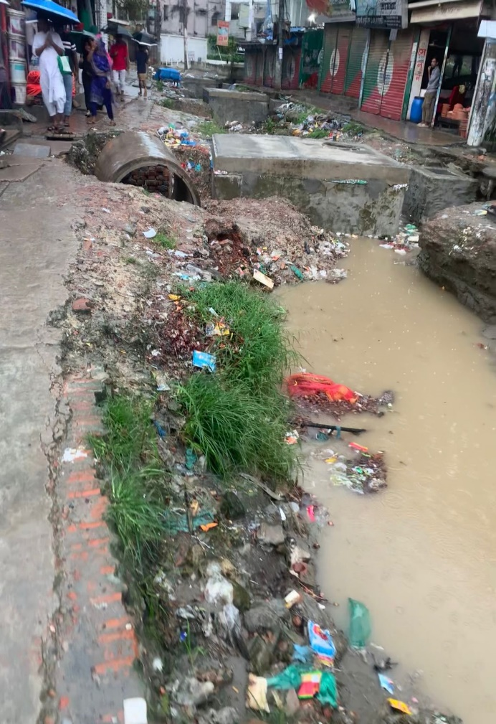

Flooded streets littered with debris (Source: Author, 2024) (Uttarkhan, Dhaka)

* **Deforestation**: The once lush green spaces in and around Uttar Khan are suffering from environmental degradation. Now, people are turning farmlands into housing and industrial sites. Here is a picture showing the transition of Uttar Khan from rural to urban: -

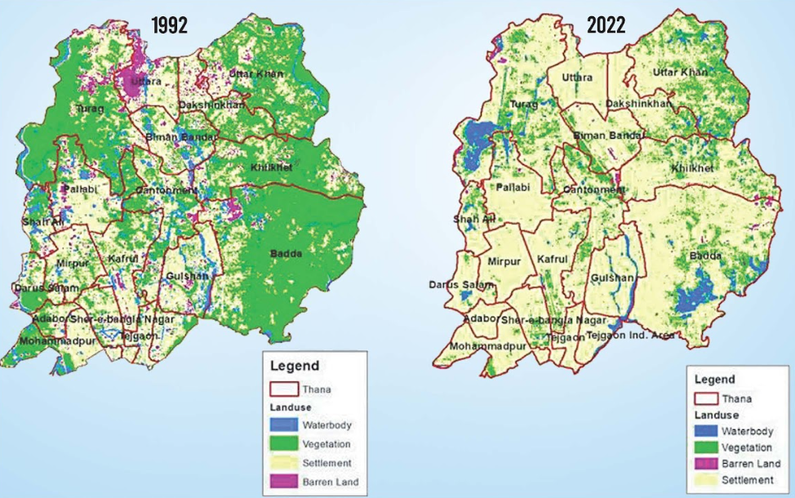

* **Noise pollution:** Road construction, industrial noise, transportation (traffic, airplanes, rail etc.) are common in Uttar Khan area which causes noise pollution. Engine, heavy machinery, drills create continuous noise. Fireworks, Loud music in public events and celebrations also causes noise pollution.
* **Waterlogging:** Uttar Khan is a lowland area. During heavy rainfall, water stays for days due to unplanned infrastructure and filling up reservoirs. Logged water polluted with solid waste, garbage, Plastics and non-biodegradable waste creates a blockage in drains. As a result, our poor drainage system becomes unable to handle the volume of water.

Aftermath of heavy rainfall in (Source: Author, 2024) (Uttarkhan, Dhaka)

# Level of pollution:

There is no doubt that a dirty environment is a curse for us. All kinds of Pollution destroy the natural food chain, biodiversity and threaten human health risk.

Poor air quality reduces visibility due to smog from open burning, industrial emission, vehicle emission. It contains SO2, NO2 that cause respiratory issues, cardiovascular diseases and premature death. Microbes can be found in the air. Public regularly suffer from breathing difficulty, eye burning around dusty environment. Air pollution has a bad impact on photosynthesis and purification of air we breathe. It also contributes to acid rain.

Water is mainly polluted because of industrial growth and urbanization. Rainwater can also mix up mining waste with ground water. Both organic and inorganic elements make water unsuitable for drinking. This leads to cholera, typhoid and diarrhea. Oil spills in water also kills fish and aquatic life. Regular wastage thrown in water is gradually destroying the water-based ecosystem. Water logging disrupts daily life and causes health issues. During rainfall the logged water becomes a burden to the urban area and creates problems in transportation.

Land pollution is linked with construction activities and disposal of waste. It affects local agriculture, soil fertility, and plant growth. Toxic chemical, plastic in land kill soil organism and pollutes ground water. Land pollution also reduces the ability to absorb water.

Waste management is a source of air pollution, water pollution and soil pollution. Waste in open space leads to long-term environmental damage. It blocks drain and canal leading to waterlogging. Toxic chemicals from waste pollute soil, spread diseases and attract pests like rats, cockroachlike. Unpleasant smell from waste discomfort residents.

Trees act as natural air filters because they absorb carbon dioxide and release oxygen. Trees also reduce urban runoff and absorb rainwater. Destroying greeneries increased temperature and creates waterlogging in and around the area. People lose shaded spots. In this low-lying area, cutting down trees can lead to flooding and disrupt regular life. Moreover, birds and other animals depending on food, nesting disappear.

In Uttar Khan, there are no zoning regulations or noise barriers. Residents, especially students living near roads or building construction sites find it difficult to focus or sleep due to noise pollution. Continuous loud noise can cause serious problems like hearing loss, sleep disturbance, high blood pressure, anxiety. Birds and small animals find it difficult to live. They migrate to quieter areas for breeding, feeding and living

# Methodology:

This case study is based on empirical investigation. In this investigation I have used many methods and sources. The methods are sources are -

* Primary data sources are

1. photo evidence
2. direct observation
3. air quality testing (IQAir website)

* Secondary data sources are
* published research, articles, Government reports
* Google maps and satellite images

# Result of the Study Area:

Standard and good AQI is 0-50. Here is a AQI test of a week summarized below:

|  |  |  |  |  |
| --- | --- | --- | --- | --- |
| **DAY** | **Pollution level** | **AQI** | **Highest temperature** | **Lowest temperature** |
| Friday | moderate | 62 | 33 °C | 25 °C |
| Saturday | moderate | 54 | 25 °C | 24 °C |
| Sunday | moderate | 72 | 30 °C | 24 °C |
| Monday | moderate | 93 | 32 °C | 25 °C |
| Tuesday | moderate | 91 | 33 °C | 25 °C |
| Wednesday | moderate | 90 | 31 °C | 26 °C |
| Thursday | moderate | 84 | 33 °C | 26 °C |

# Positive initiatives:

Several initiatives have been taken by Government bodies, NGO’s and private sectors to address environmental pollution in Uttarkhan. Dhaka North City Corporation (DNCC) has implemented community-based waste management schemes to tackle pollution issues, particularly focusing on solid waste management. These schemes aim to reduce pollution in rivers by improving waste disposal practices. DNCC’s Disaster Risk Reduction (DRR) plan emphasizes raising awareness at the community level about environmental hazards. It helps to restore green spaces like parks and playgrounds. Also, improve air quality and reduce seasonal floods (Source: UNDRR). World Bank and local authorities arranged programs to target pollution sources such as brick kilns and vehicular emissions (Source: World Bank).

# Discussion:

Insufficient engagement and awareness restricting to produce change across the area. Though various initiatives have been taken, there are some drawbacks. There is a lack of co-ordination and overlapping responsibilities among Government agencies. There are weak enforcement and environmental regulations. Industries and households often violate guidelines of waste disposal due to less monitoring. Financial limitations also restrict the scope of environmental programs in Uttar Khan (Source: UNDRR). Moreover, environmental programs rely on outdated technologies for proper execution.

# Conclusion:

The study ends on environmental concerns in Uttar Khan, a rapidly populated part of Dhaka metropolis. Air pollution, water pollution, land pollution, noise pollution, and deforestation all have a substantial impact on the health and well-being of humans and wildlife. So, constructive measures such as increasing air quality, purifying water, and managing trash are required for an environmentally friendly world. Green measures, such as planting trees and public awareness campaigns, will not only enhance urban life but also contribute to balancing the ecology. The government, local organizations, and the general public should work together to make Uttar Khan a role model for sustainable development in Dhaka City.

Implementing beneficial initiatives will have a transforming influence on the Uttar Khan environment. Vehicles and factories, coupled with tree planting, will help to minimize air pollution and hazards to public health. After water treatment, rivers will provide clean water. Construction of water filters and sanitation systems will ensure a healthy lifestyle. Cholera, diarrhea, and other waterborne infections can be prevented with safe and clear water. Farmers will also profit from better soil quality. Sustainable waste management systems will create a hygienic and breathing atmosphere while also reducing the spread of illness. A tree plantation will reduce heat, urban runoff, and flood risk. The planned infrastructure and drainage system will help to reduce waterlogging. Reducing noise contributes to improved workplace performance, less stress, better sleep, and general well-being. Public participation will contribute to a greener environment. Cleaner air, water, and soil will result in a more beneficial ecosystem for both humans and wildlife.